**Categorical Data Analysis**

**Homework 2 (一組交一份作業)**

**Due: 12/27 5PM @統計系系辦外作業信箱**

1. **Problem 2.2 on Applied Logistic Regression.**

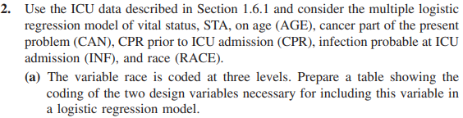

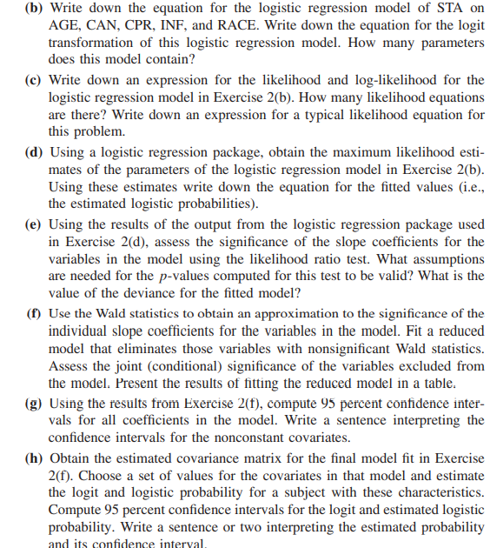

1. **Problem 3.5 on Applied Logistic Regression.**

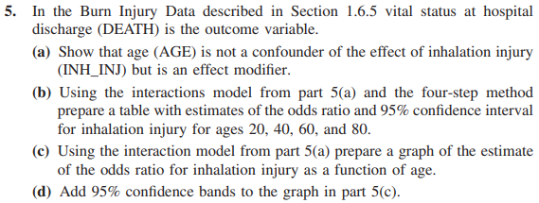

[**https://github.com/kindermatik/AppliedLogisticRegression/blob/master/HomeworkWeek3.pdf**](https://github.com/kindermatik/AppliedLogisticRegression/blob/master/HomeworkWeek3.pdf)